Chapter 2, Problem 67.

- Obtain the voltage v_{o} in the circuit of Fig. 2.127(a).
- Determine the voltage v’_{o} measured when a voltmeter with 6-kΩ internal resistance is connected as shown in Fig. 2.127(b).
- The finite resistance of the meter introduces an error into the measurement. Calculate the percent error as
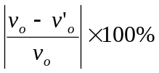.

(d) Find the percent error if the internal resistance were 36 kΩ.

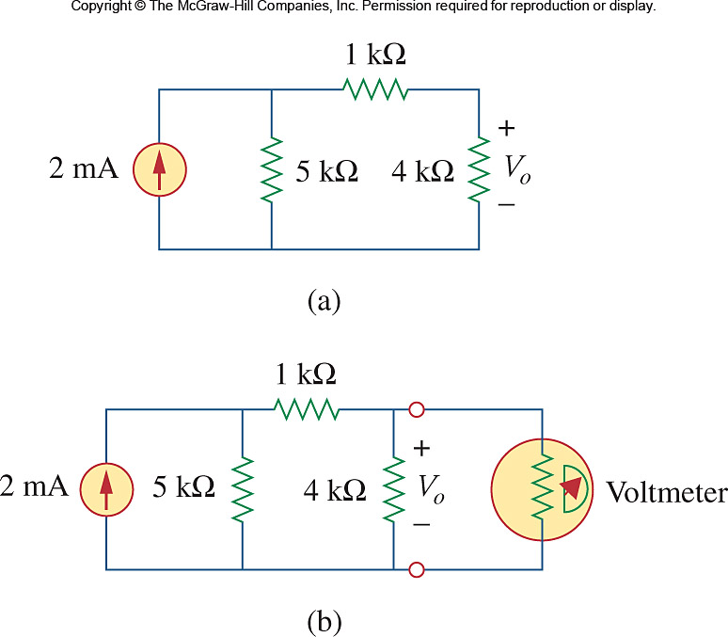

Figure 2.127
For Prob. 2.67

